This is my feedback to my last tutor.

I have received the first feedback from my professor FOR THE ESSAY PAPER#2 AND NOT SHORT WRITING ASSINGMENT, and it is kind of bad news. He said that you needed to start again from the beginning because overall was not what the prompts asked you to do. He said that it was more wasting time and effort to revise them because every paragraph was more like a summary. The reasons are:

- The prompt asks you to analyze the significance of wars (WW2 is too broad); can you explain about Vietnam war in the revision? Your latest work was more like a summary of the class material. Each paragraph has to start with a strong thesis based on your argument in analyzing the significance of war and how it has shaped or impacted the particular Asian ethnic group experiences. There is also material about Vietnam on the PowerPoint slide on Canvas. Please read it.
- It has to be a specific group. For example, you only talk about Vietnamese.
- In each paragraph, your paper MUST consist of a clear/ strong thesis, supported by your own reasons, and backed up by evidence drawn MINIMUM ONE from the reading. For illustration, you give a strong thesis on your analysis of the significance of the Vietnam War toward the Vietnamese. For example, what happens before and after this war, and what are the impacts for them. Then each paragraph, you tell your reason. Also, in each paragraph, there must be a least one supporting evidence from the course reading. For most of your paragraph, there is no evidence at all. Please remember that the evidence is drawn from at least THREE different readings.
- Also, your paragraph was too short. Each paragraph has to have a strong main thesis, your reason, and the evidence from the book.
- Some of your formattings were wrong. Please see the WRITING GUIDELINES.
- You have to remember that this paper aims to persuade readers to think differently based on your own argument or perspective on the prompt. Not summarize. You have to emphasize what do you think about it more.
- THINK OF YOUR ESSAY WHICH YOU SEEK TO PERSUADE OR CONVINCE YOUR READER BASED ON YOUR PERSPECTIVE.

I know that some of them it was my mistake since I did not give you clear explanations. Therefore, after you finish with this, I will give you a good amount of bonus as my apologies to you. I need you to complete it asap because of the deadlines. Thank you! Please read the instructions carefully.

Please read:

THE PAPER IS GRADED ON HOW YOU UNDERSTAND THE MATERIAL’S CONCEPT TO CONVINCE YOUR PERSPECTIVE TO THE READERS BASED ON THE PROMPT. MY PROFESSOR WANTS TO KNOW WHETHER YOU HAVE COMPREHEND THE MATERIALS’S CONCEPTS OR NOT AND HE GRADED IT BASED ON THAT WAY. IT IS NOT GRADED BASED HOW WELL YOU DO THE SUMMARY; IT IS NOT WHAT THE PROMPT ASKS. THEREFORE, THERE IS NO CORRECT OR WRONG ANSWER. YOU HAVE TO BE MORE CRITICAL IN DOING THIS. THANK YOU!

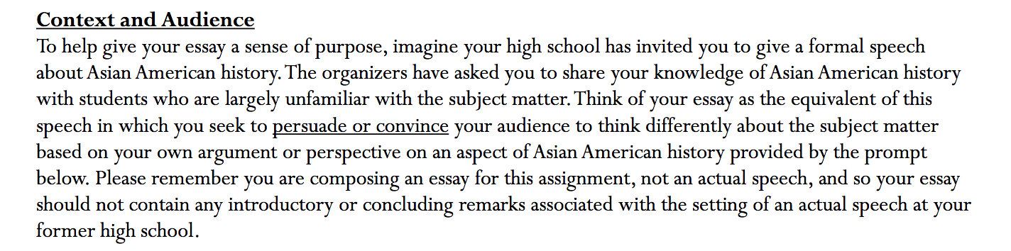
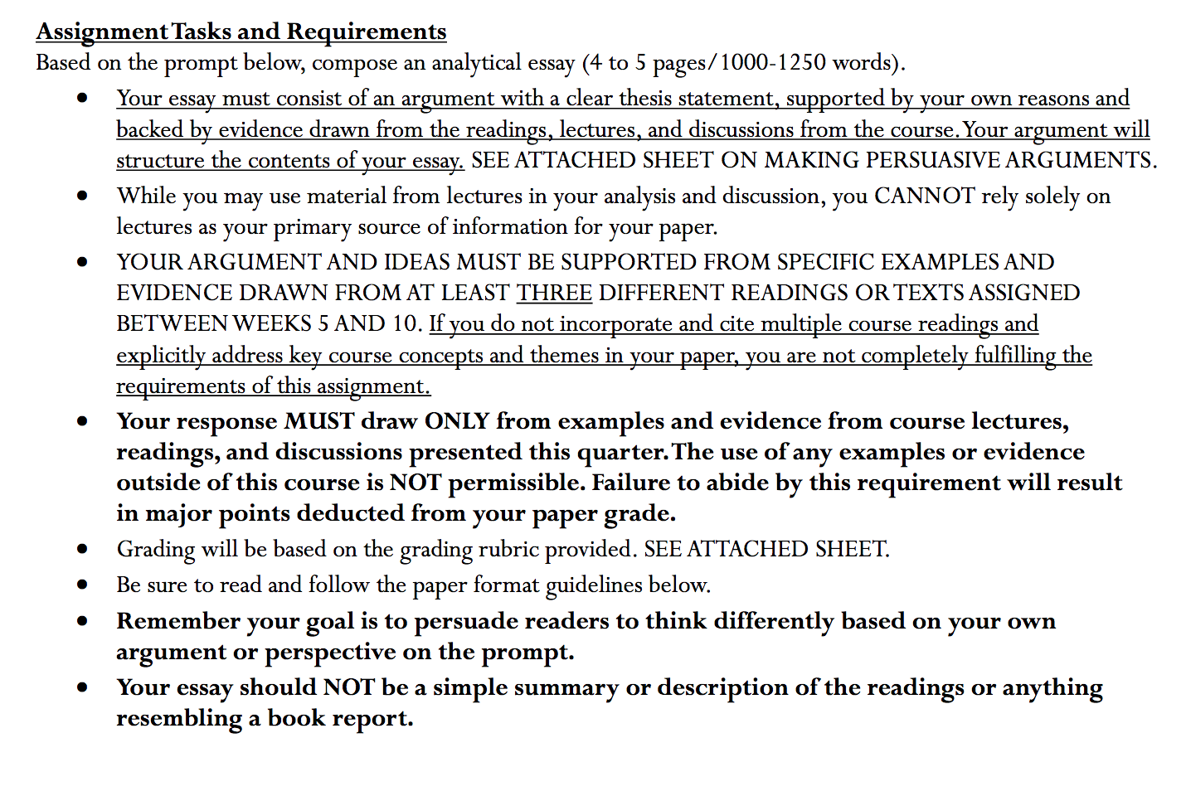
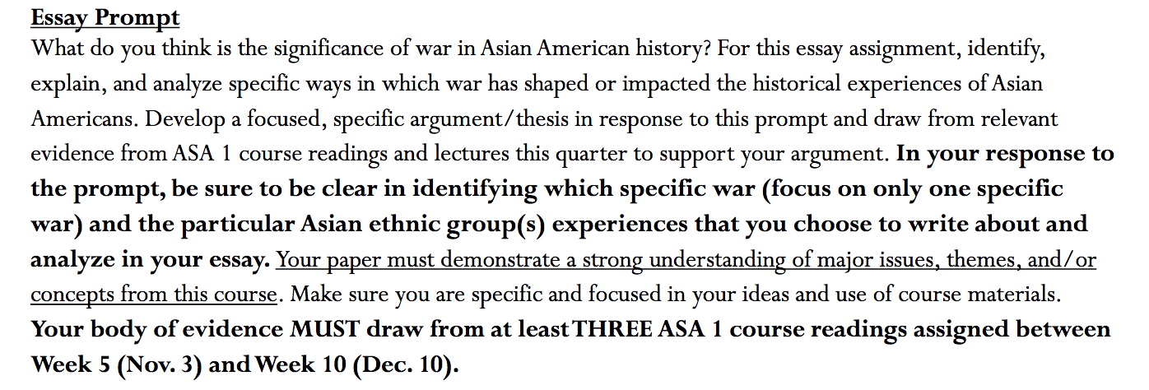

You are NOT SUMMARIZING. THIS IS AN ARGUMENTATIVE PAPER, WHERE YOU GIVE YOUR ARGUMENT AND CLEAR THESIS BASED ON THREE DIFFERENT COURSE READINGS. PLEASE READ!
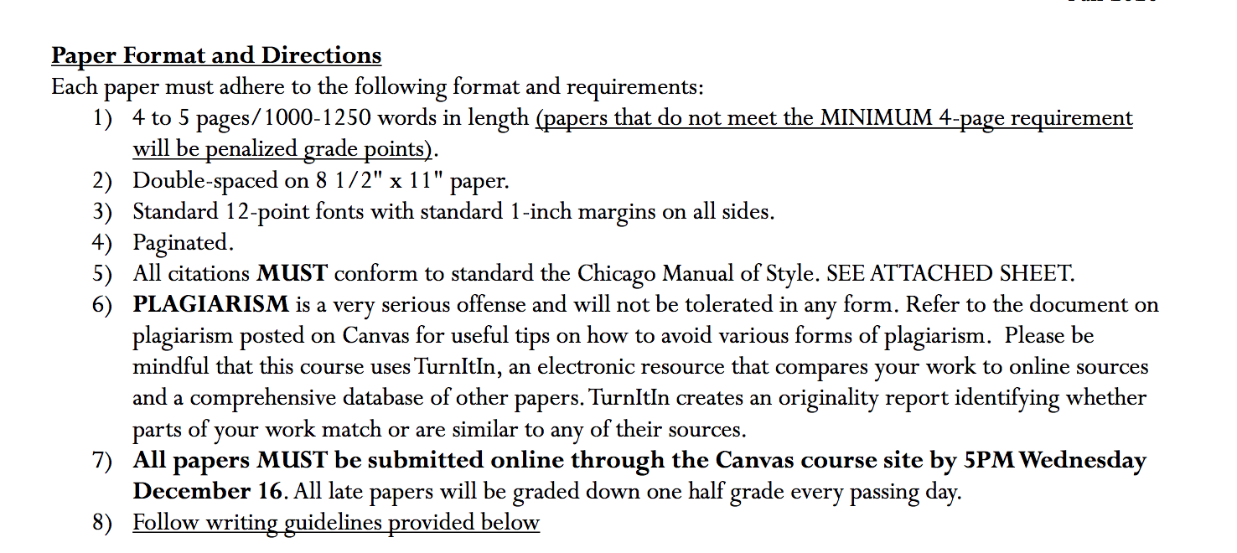

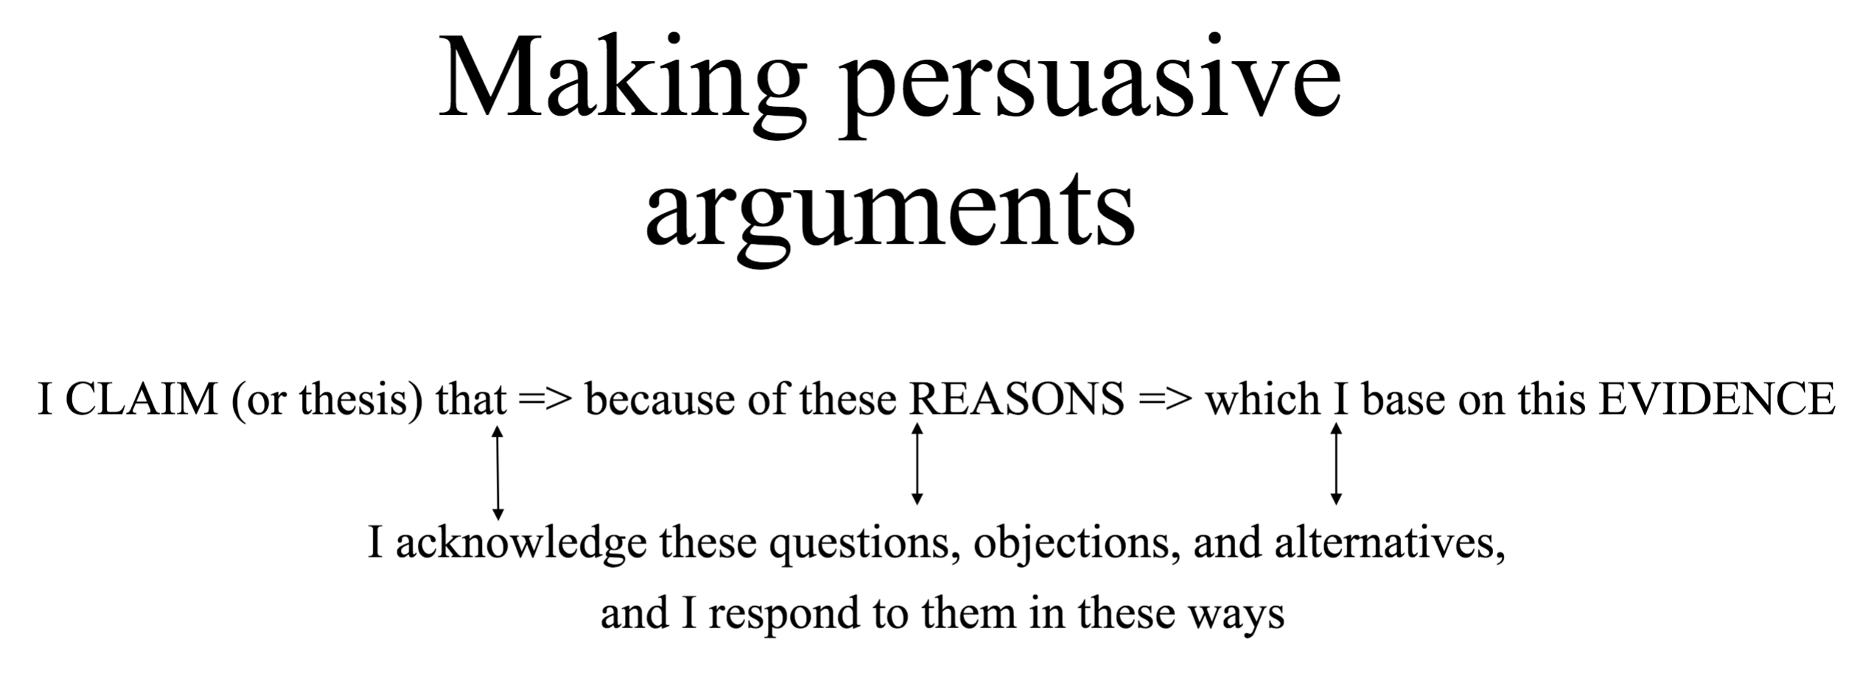

Your body of evidence must draw from at least THREE course reading assigned below!

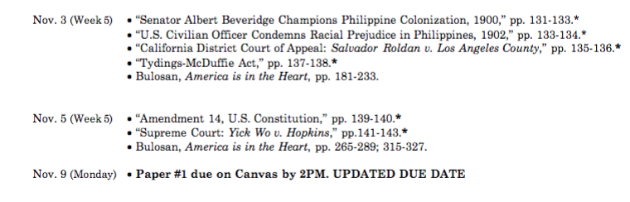

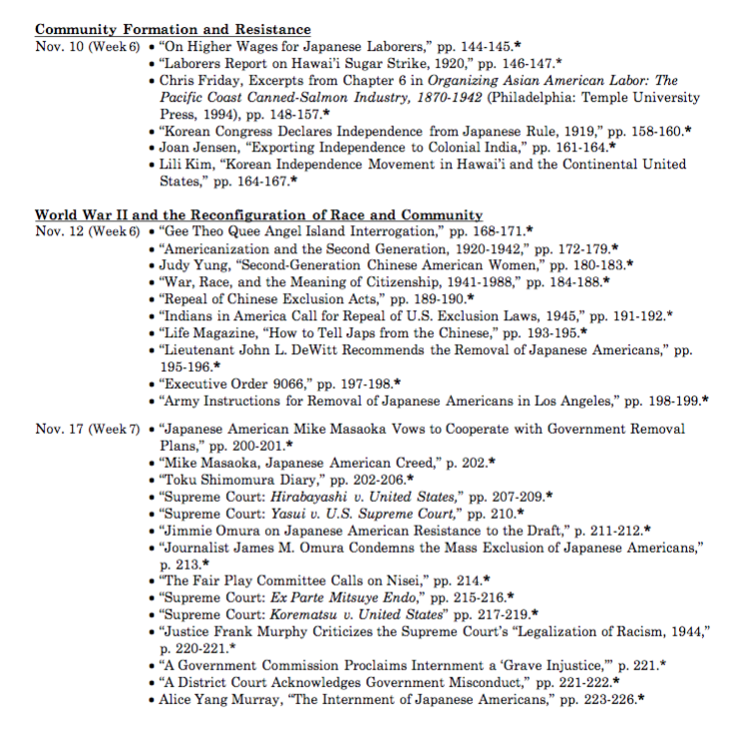

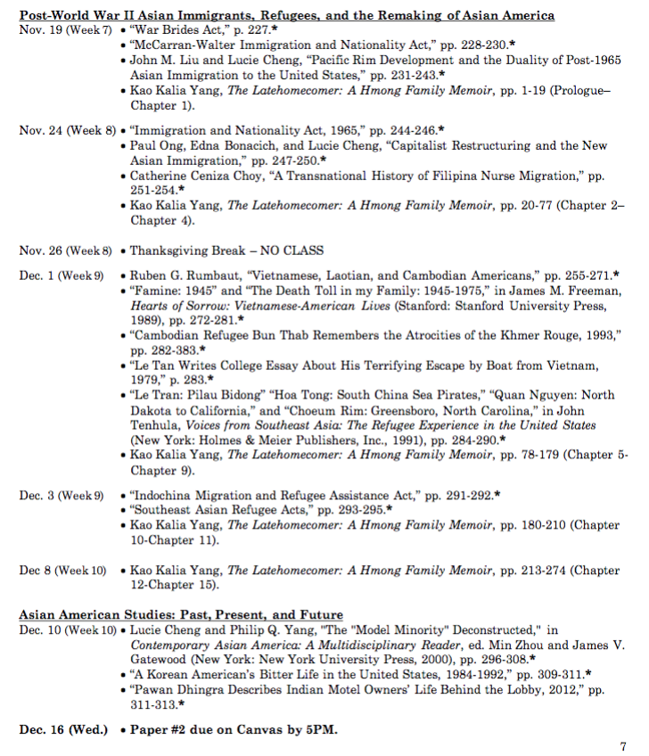

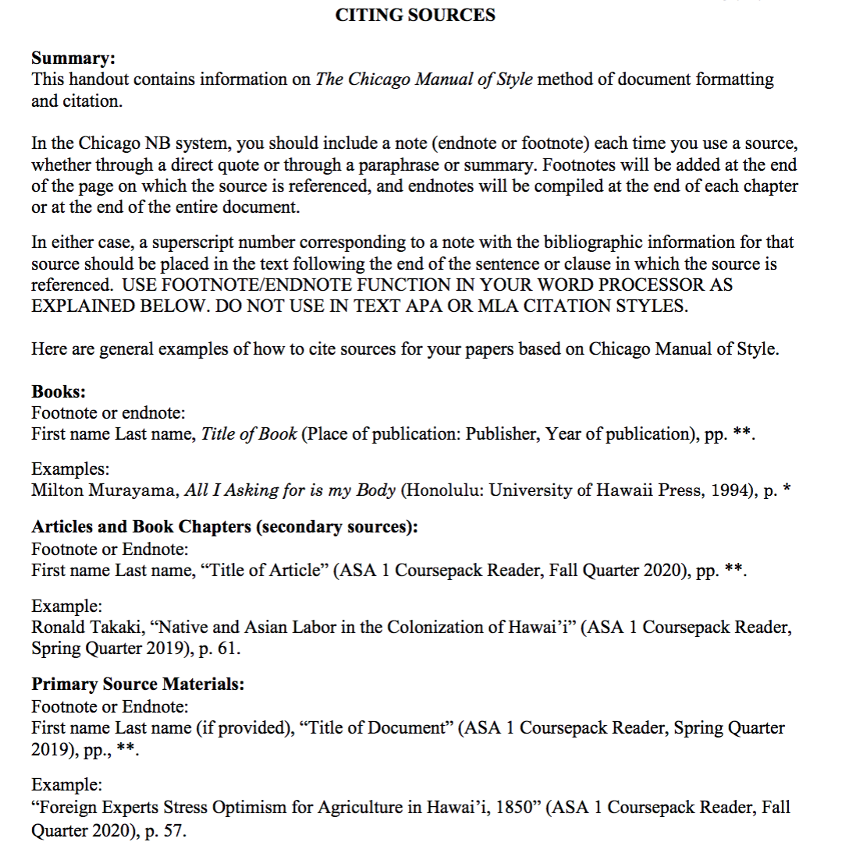

How to Access

Please see this link for the prompt and instruction!
https://canvas.ucdavis.edu/courses/511303
Then
UCD Login, which is the left one

Then
Username: sfelix
Password: GBumiPermai@F4/2

Then
See ASA 1 Paper #2 Prompt Essay Assignment.pdf in the bottom of the page

For paper #2
Please reread again the prompt, so you can understand more what the prompts ask you about
Also, do not forget to use “Insert Footnote” Function for the citing quotes. The quote must be following the “The Chicago Manual of Style method.” See the instruction on how to quote.

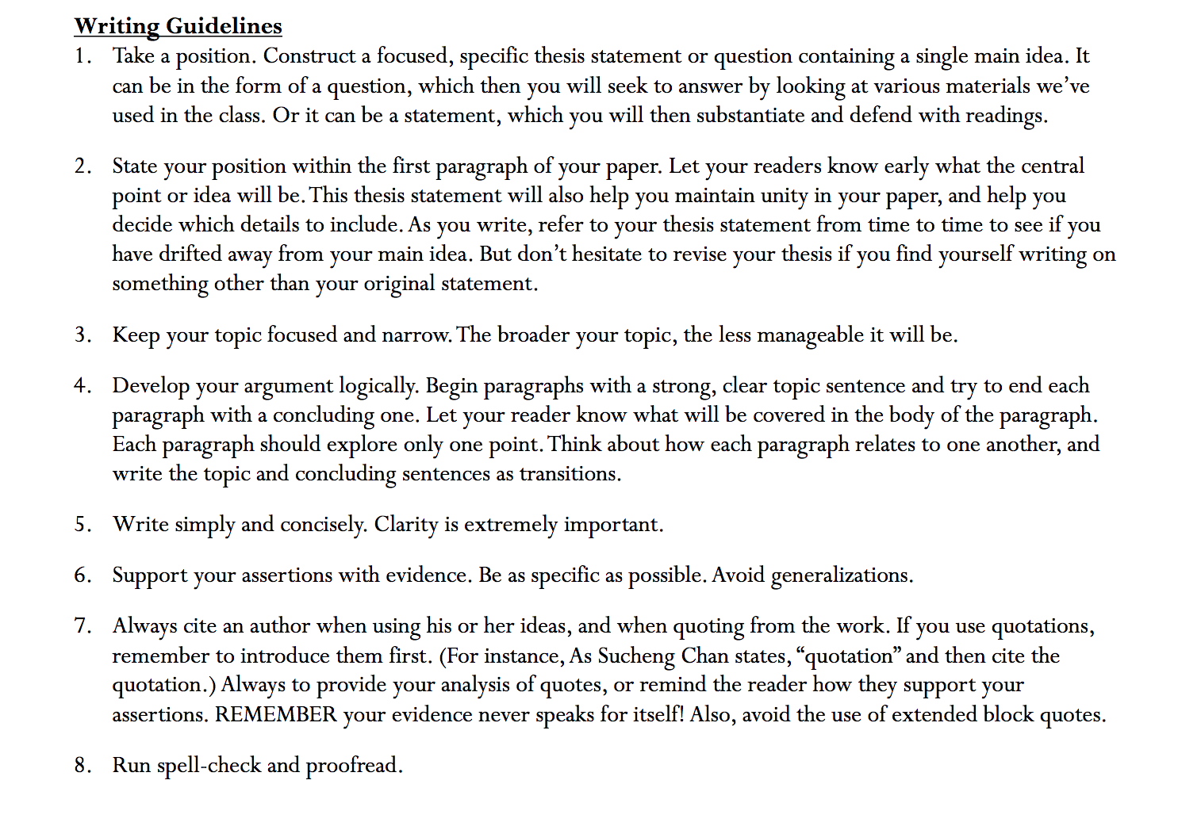
Here are points that you must read

To make it clear,

For point 1, please read it because the instruction is clear already.
For point 2, it says that for your first paragraph, please make a thesis that is the central of the paper, so your audience knows the points you will deliver. Again it is not a summary, but your analysis/ argument toward the prompt.
For point 3, sometimes your points are too broad. Please make it more specific by being more critical.
For point 4, as I tell you that please begin the paragraph with a clear topic sentence. EACH PARAGRAPH SHOULD ONLY EXPLORE ONE POINT. Most of your paragraph was too short, which made them not strong enough to convince or persuade the readers. Again, each paragraph consists of a clear topic sentence, your reason, and backed up with at least one piece of evidence from the reading. The reading purpose’s just to support your argument by telling the evidence. Please do not need to summarize the reading or telling what happens in the reading. Instead, you suppose to give analysis or argument about the prompt and show that the reading also supports your argument. This is graded on how you able to convince/ persuade your readers about your analysis toward the prompt.
For point 6, avoid generalization. Your paper #1 was too broad, and they were most summary, not analysis.For point 7, see how to quote and avoid the use of extended block quotes. “Do not organize your paper according to the readings you are using, but rather by the larger themes of your argument.”
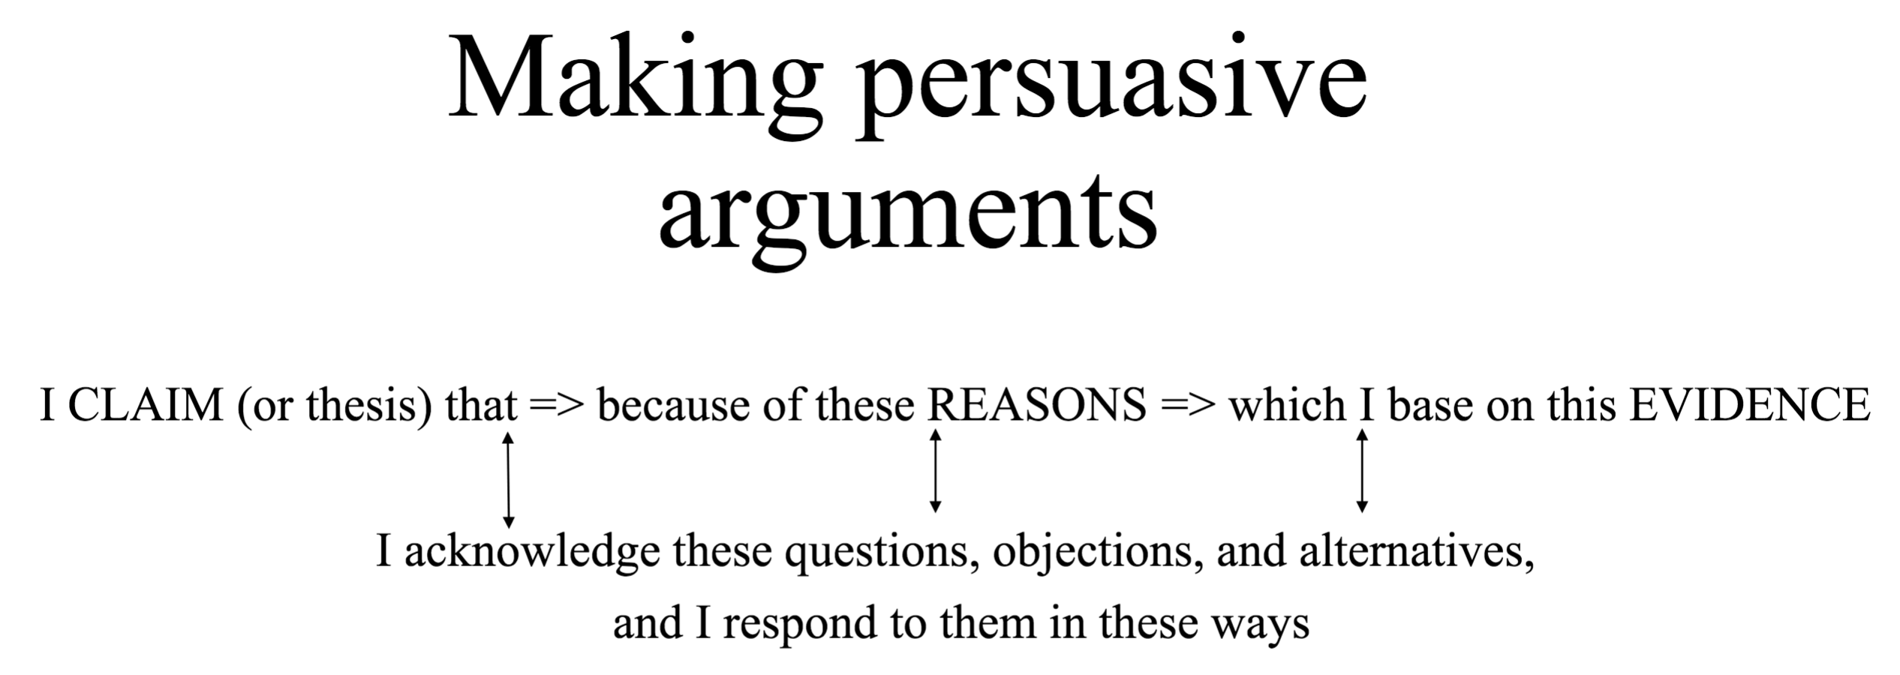

Here is the feedback from my professor regarding Short Writing Assignment 2, which the issues in SWA#2 are just the same as your issues in Paper#2:

"Your paper seems to focus a lot on summarizing details, mainly those of the Flora Belle Jan reading. You don't get to the argument until the end of your first page and into your second page. Your first paragraph goes right into Flora Belle Jan, but does not establish your argument for the remainder of the paper.

If I were you, I would focus on revising to have less description of examples and more analysis. Organize the paper so that the reader knows exactly what your argument is at the very beginning of the paper, within the first paragraph. Do not organize your paper according to the readings you are using, but rather by the larger themes of your argument."

For the illustration, so you know the concept of this paper:

